Activity Logs Module

September, 2023

# Overview

The Activity Log serves as a comprehensive tool for monitoring all user actions within the platform. Gain insights into each action with detailed timestamps and user-specific activities for a thorough overview.

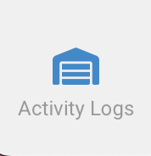

# Filter user activity

Use the search bar to filter user activity by username, action, or time interval

# Activity log timestamps

Detailed overview of user activities showcasing specific actions taken by each user along with corresponding timestamps.

# How to

1. Filter activity log

To filter activity log using search bar:

* Search using user or activity
* Click the filter button to filter by interval
* Use the arrow button beside the timestamp column to filter in ascending/descending order.